**Task Description#1**

* Try 3 different prompts to generate a factorial function.

**Expected Output#1**

* Comparison of AI-generated code styles

1ST PROMPT :

write a python function which calculates the factorial of a given number and read input from the user.

CODE :

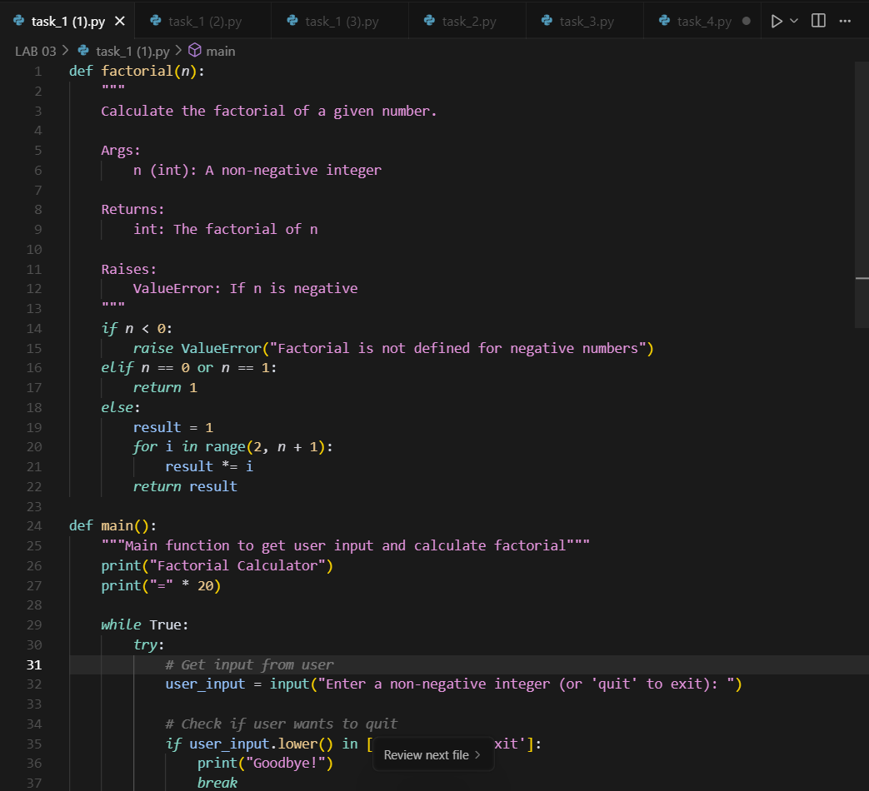

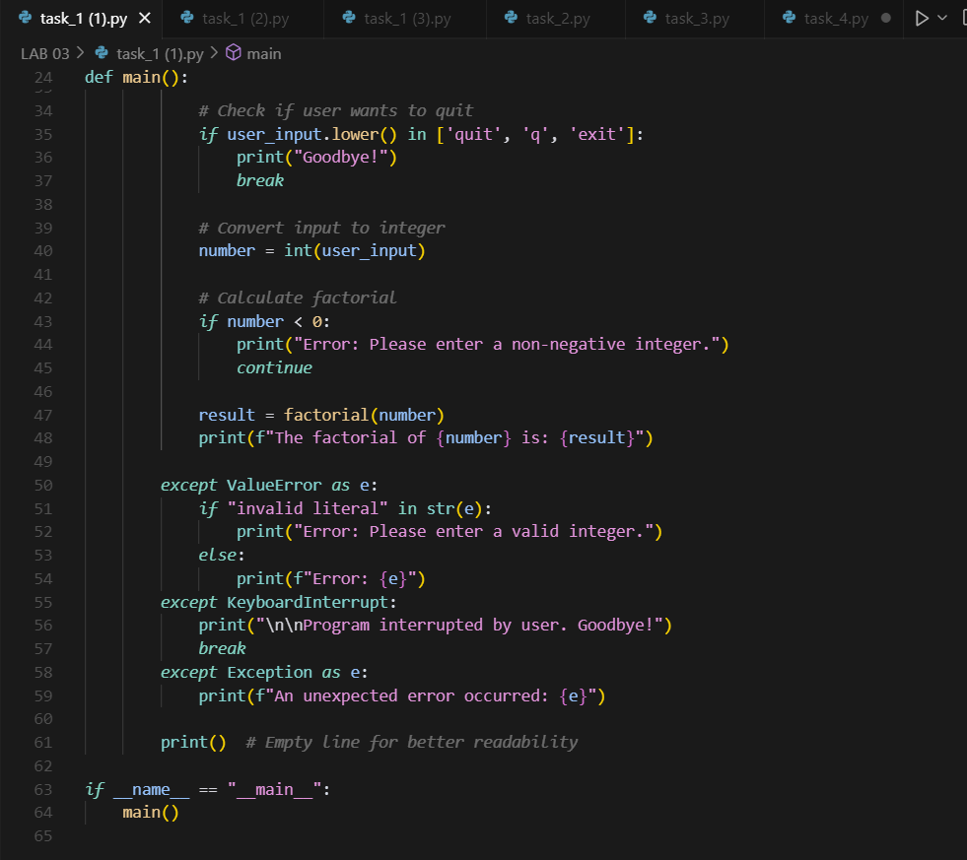

OUTPUT :

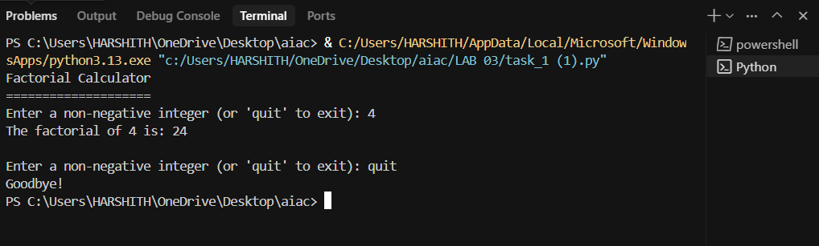

2ND PROMPT :

Write a Python program that asks the user for a number and prints its factorial

CODE :

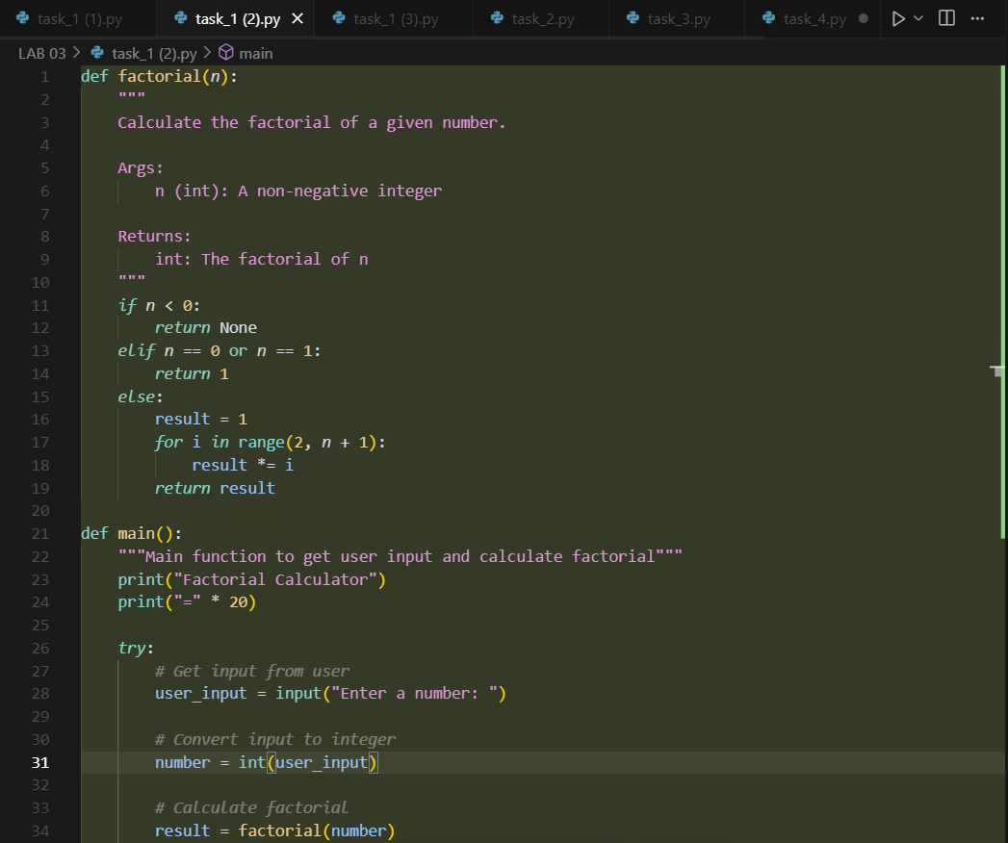

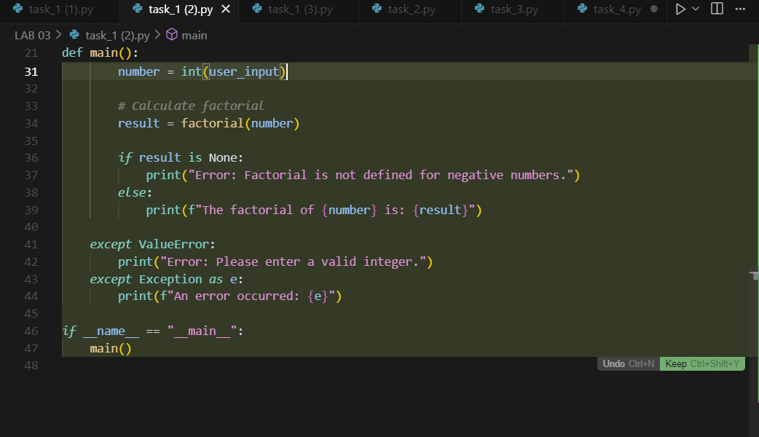

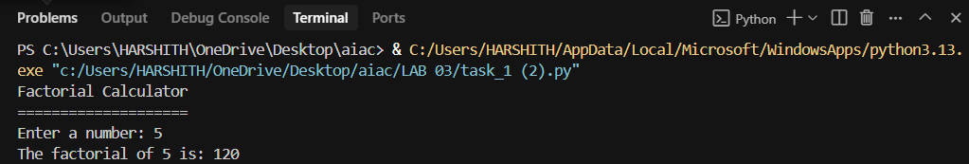OUTPUT :

3RD PROMPT :

Write a Python function that calculates the factorial of a number using recursion. Assume the input is a non-negative integer.

CODE :

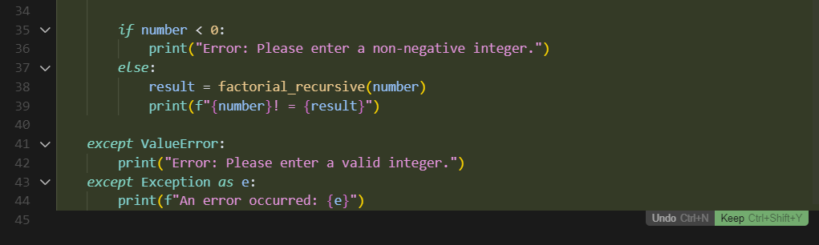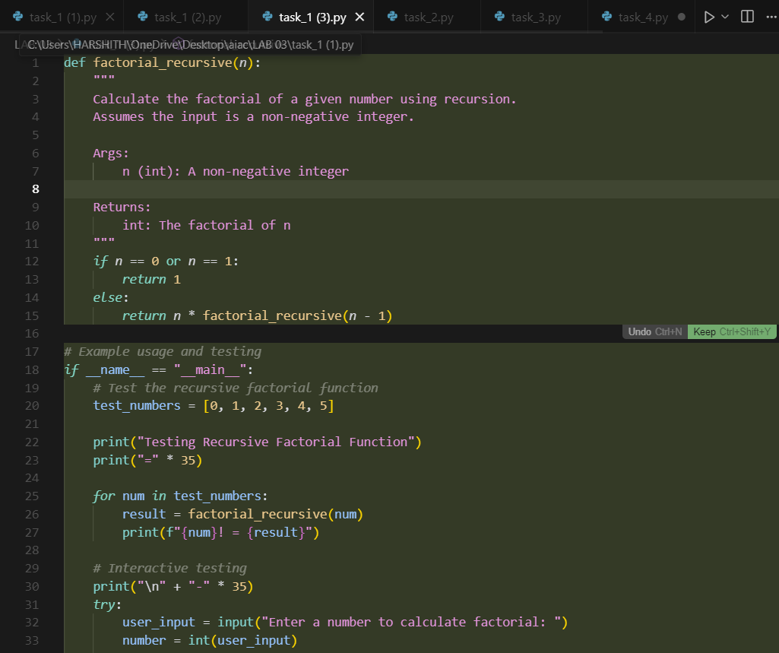

OUTPUT :

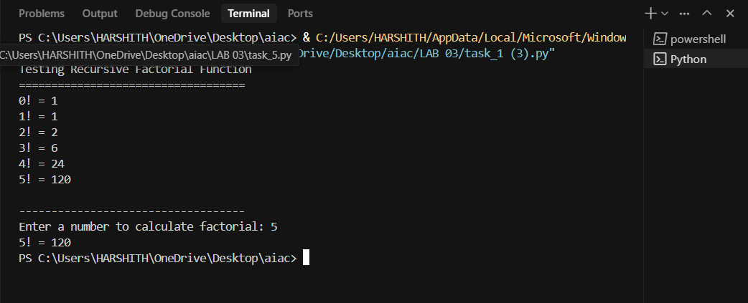

**Task Description#2**

* Provide a clear example input-output prompt to generate a sorting function.

**Expected Output#2**

* Functional sorting code from AI

PROMPT :

**Write a Python program that takes a list of numbers from the user and shows a menu to choose how to sort : ascending, descending, odd numbers, or even numbers. Then display the result based on the user's choice.**

**CODE :**

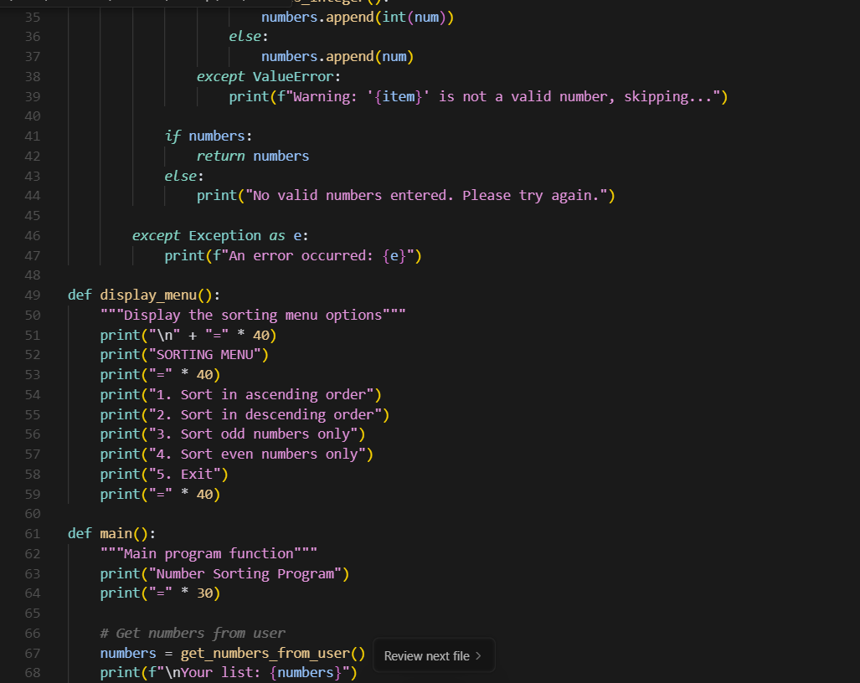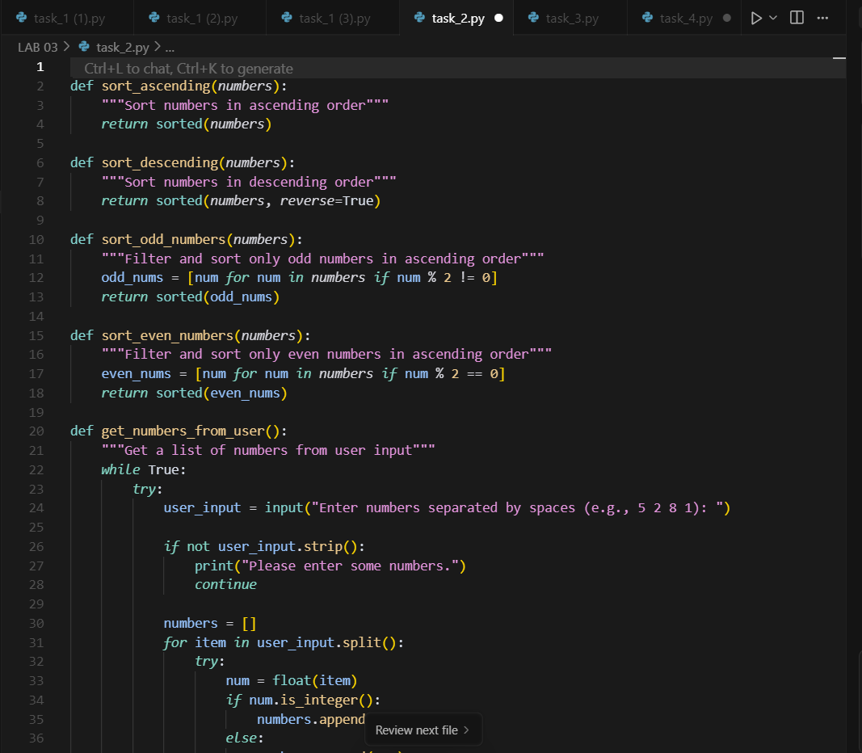

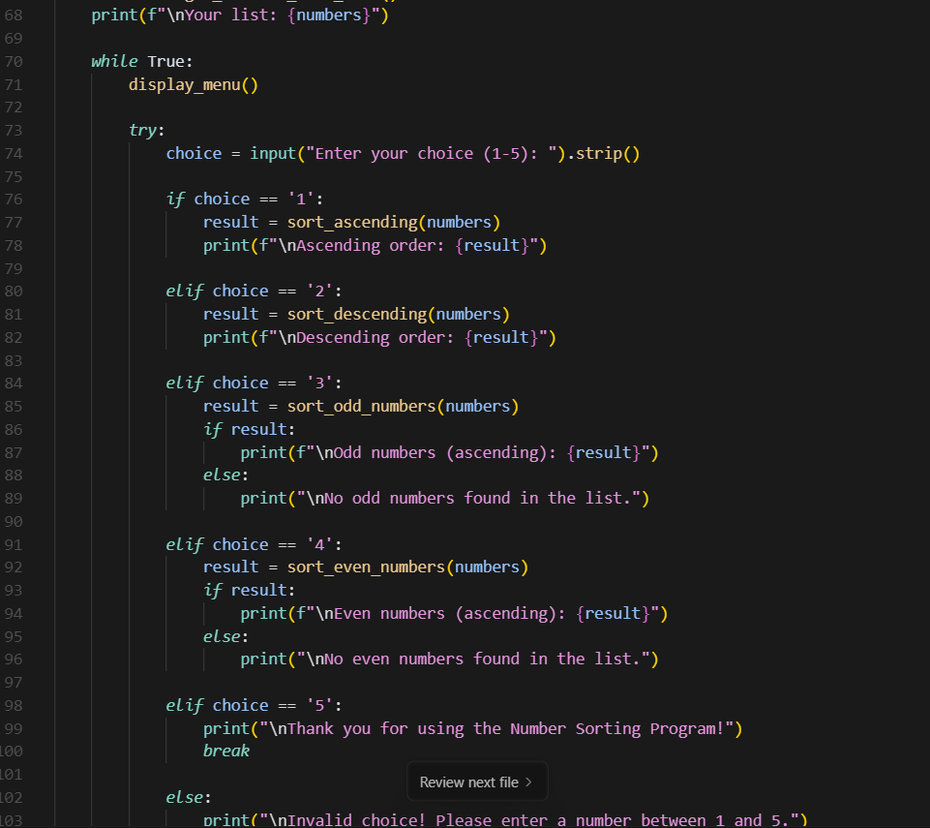

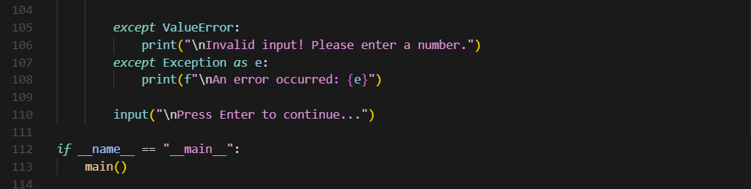

OUTPUT :

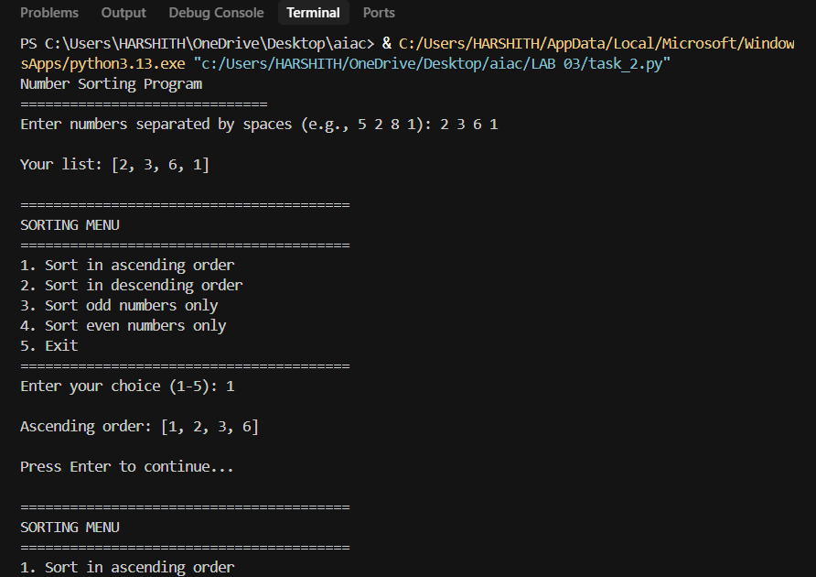

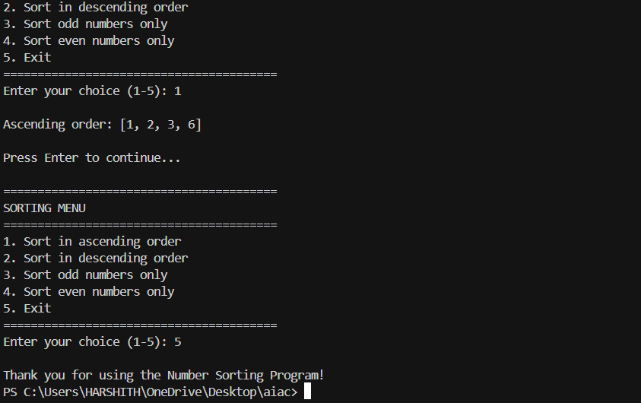

**Task Description#3**

* Start with the vague prompt “Generate python code to calculate power bill” and improve it step-by-step

**Expected Output#3**

* Enhanced AI output with clearer prompts

PROMPT :

Write a Python program to calculate a customer's power bill. Include a function to collect customer details, a function to show previous bill details, and a function to calculate the current bill based on units consumed.

CODE :

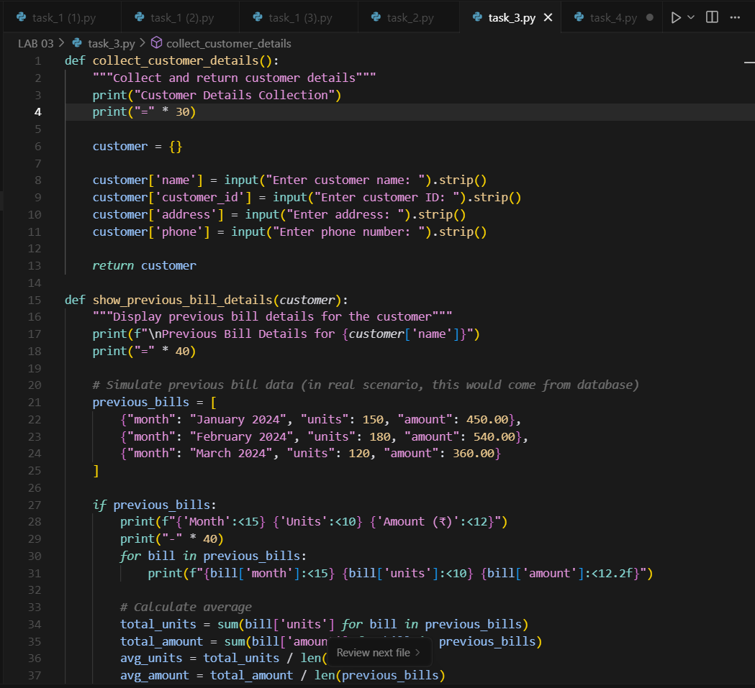

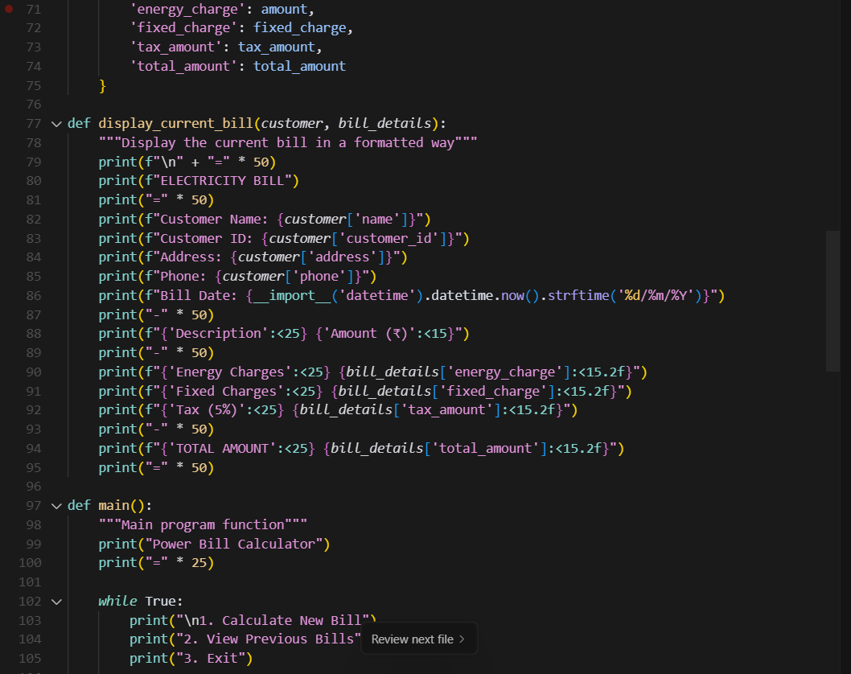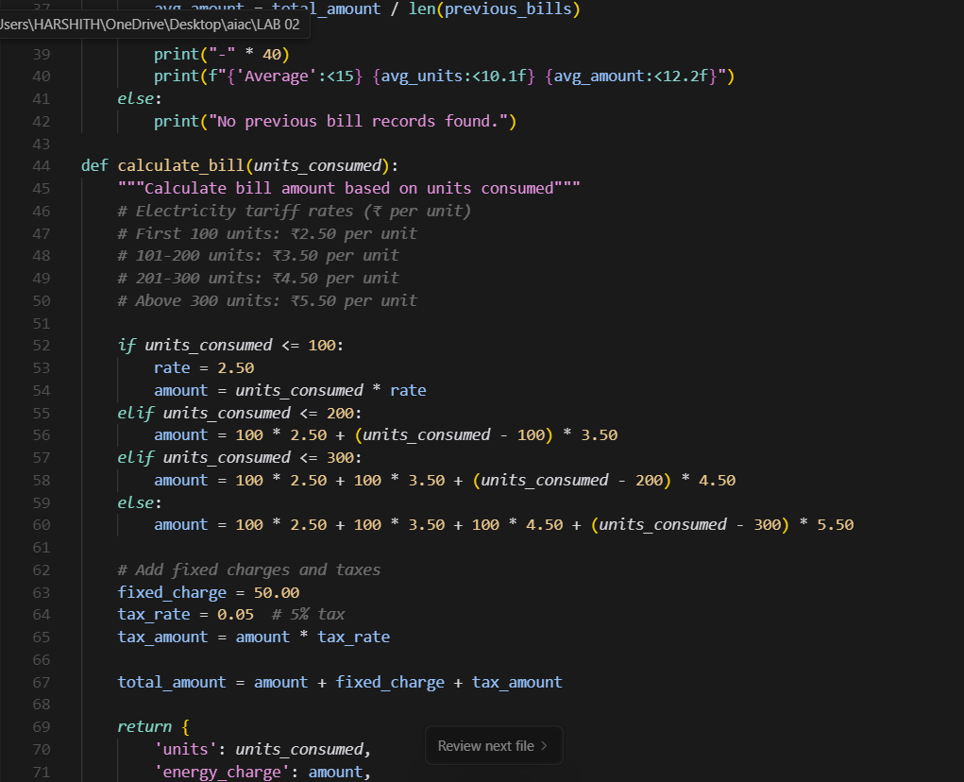

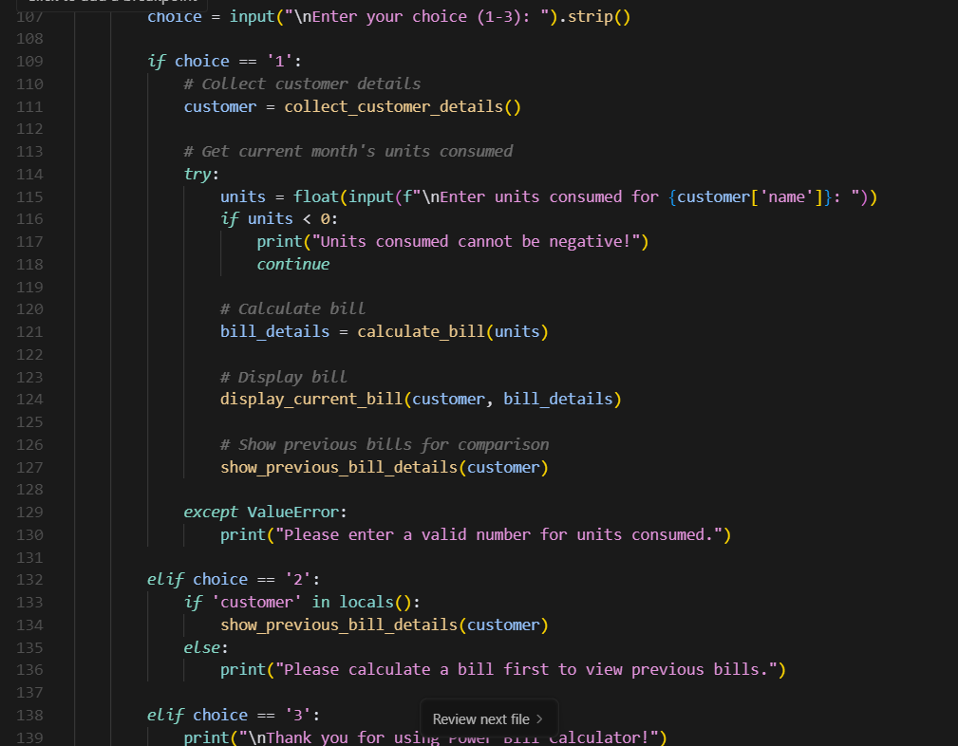

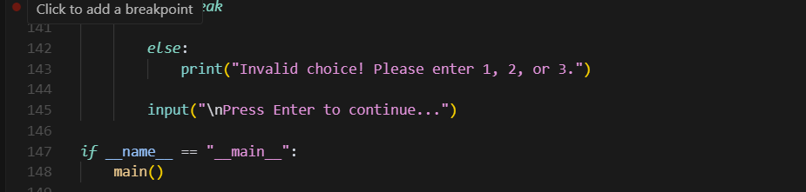

OUTPUT :

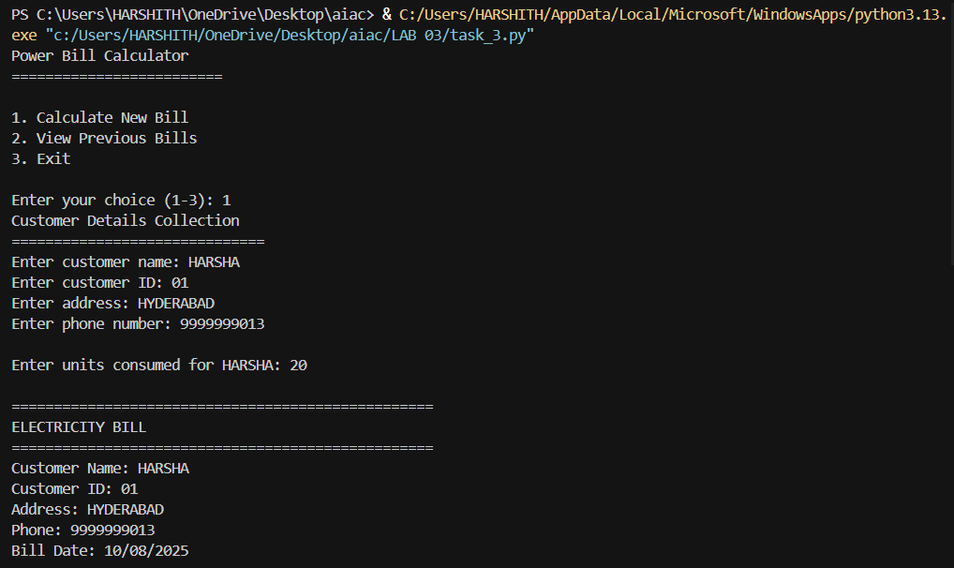

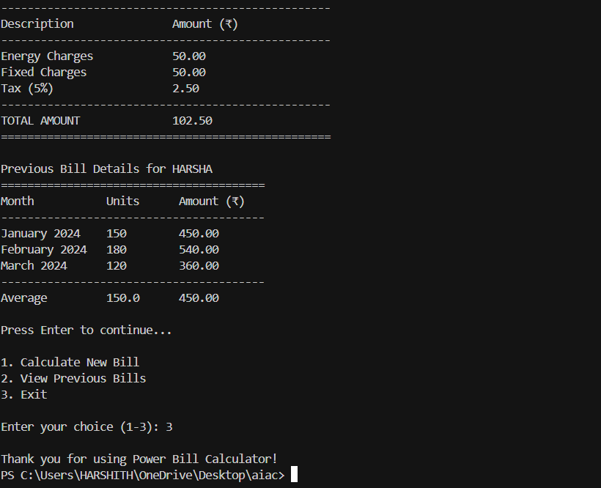

**Task Description#4**

* Write structured comments to help AI generate two linked functions (e.g., login_user() and register_user()).

**Expected Output#4**

* Consistent functions with shared logic

PROMPT :

Write Python code with two functions: register_user() and login_user(). Add comments to explain how usernames and passwords are handled.

CODE :

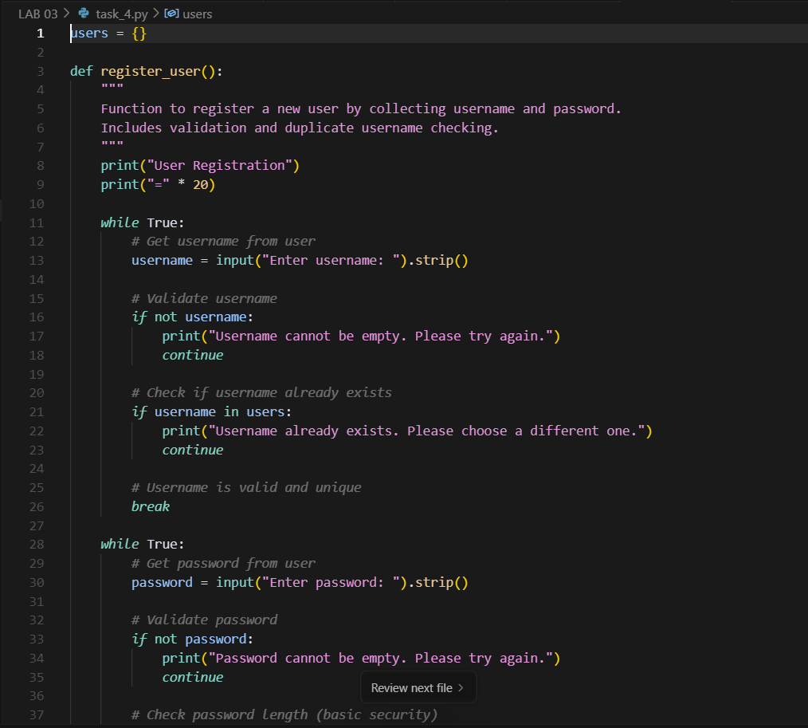

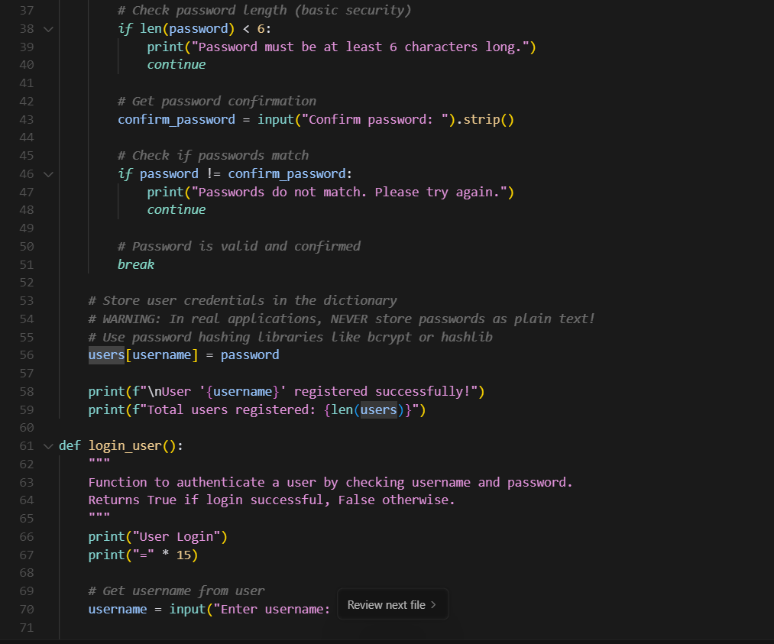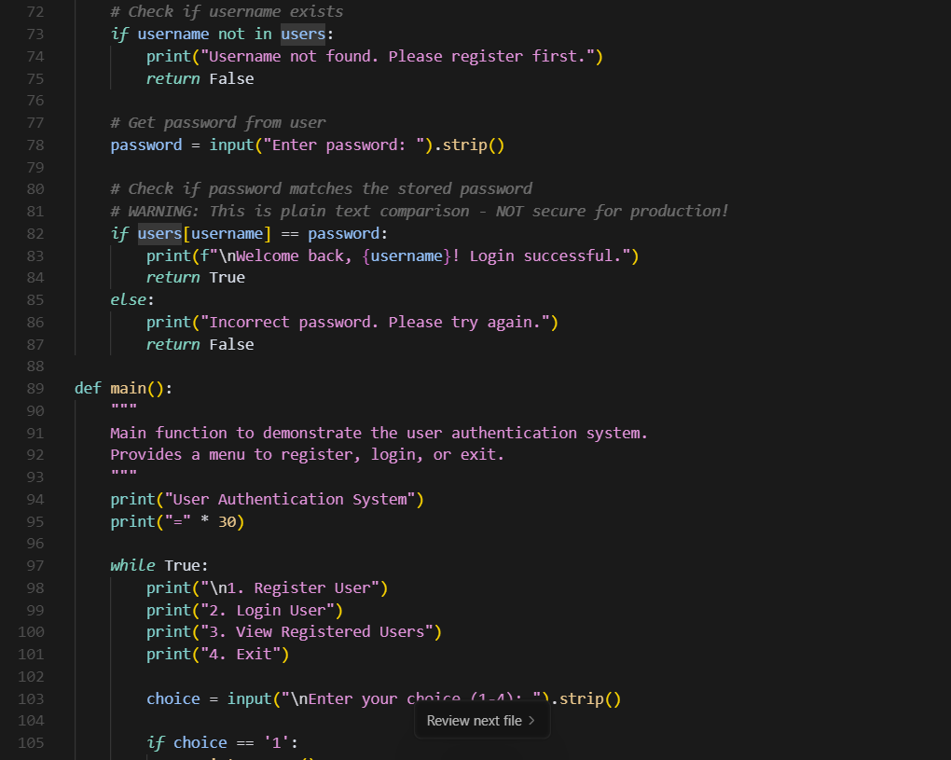



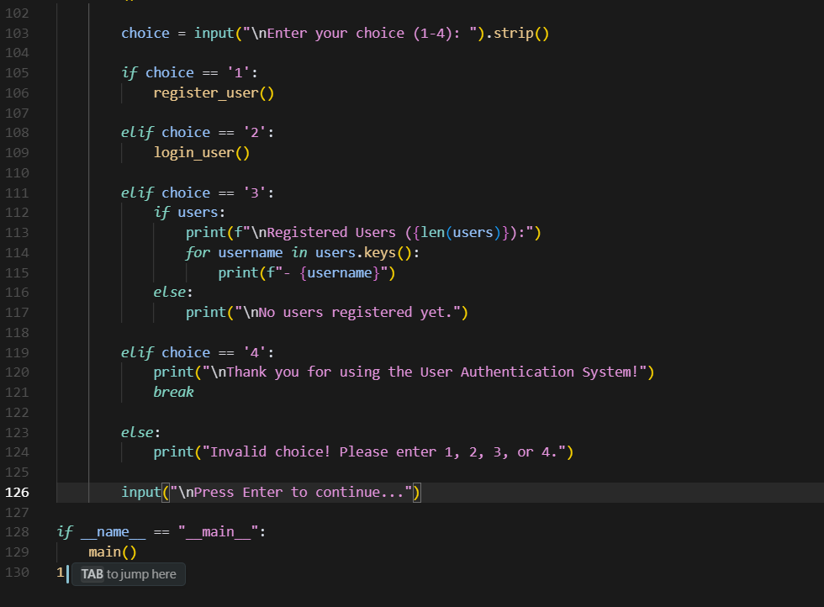

OUTPUT :

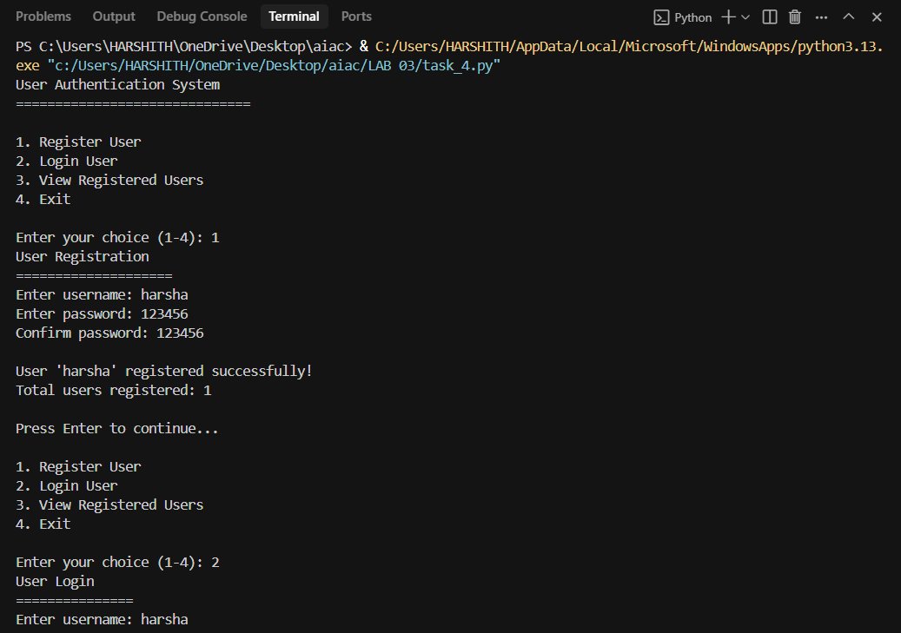

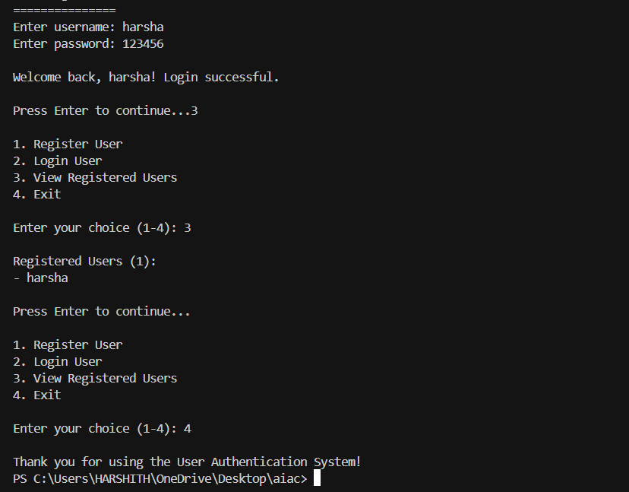

**Task Description#5**

* Analyzing Prompt Specificity: Improving Temperature Conversion Function with Clear Instructions

**Expected Output#5**

* Code quality difference analysis for various prompts

PROMPT :

Write a Python program with a temperature conversion function and a menu that loops until the user chooses to exit.

CODE :

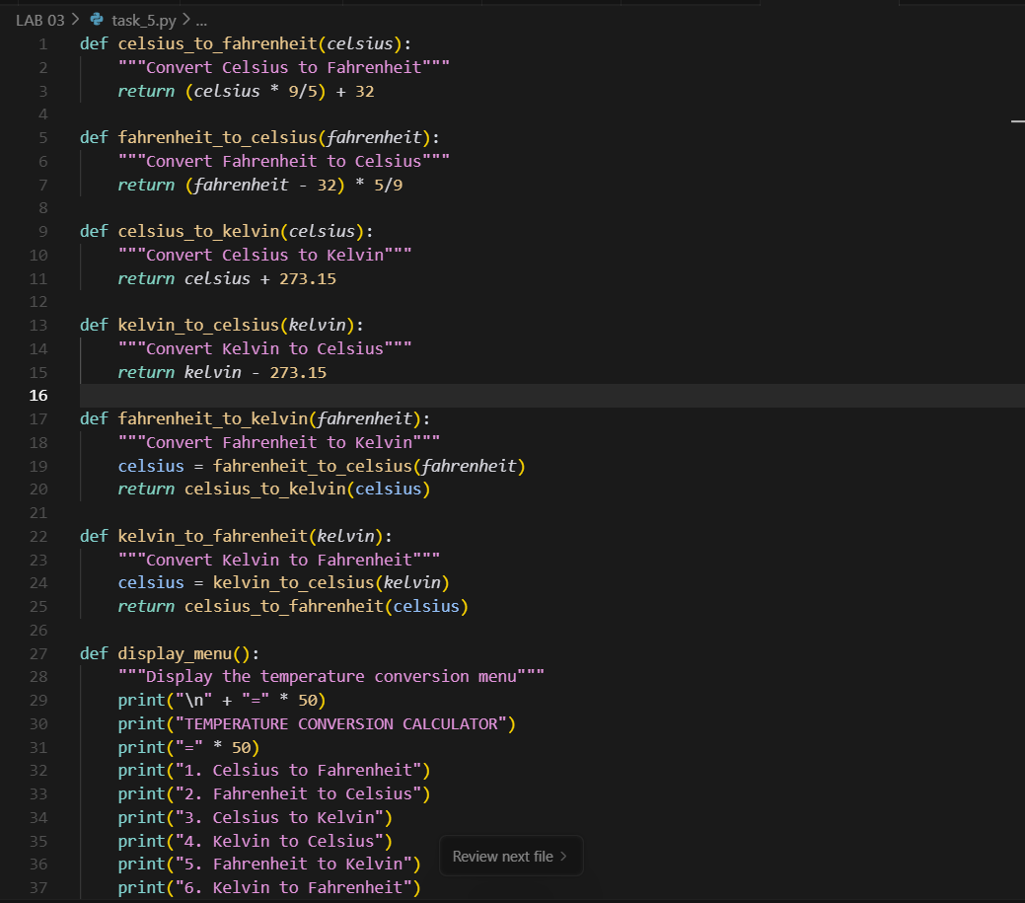

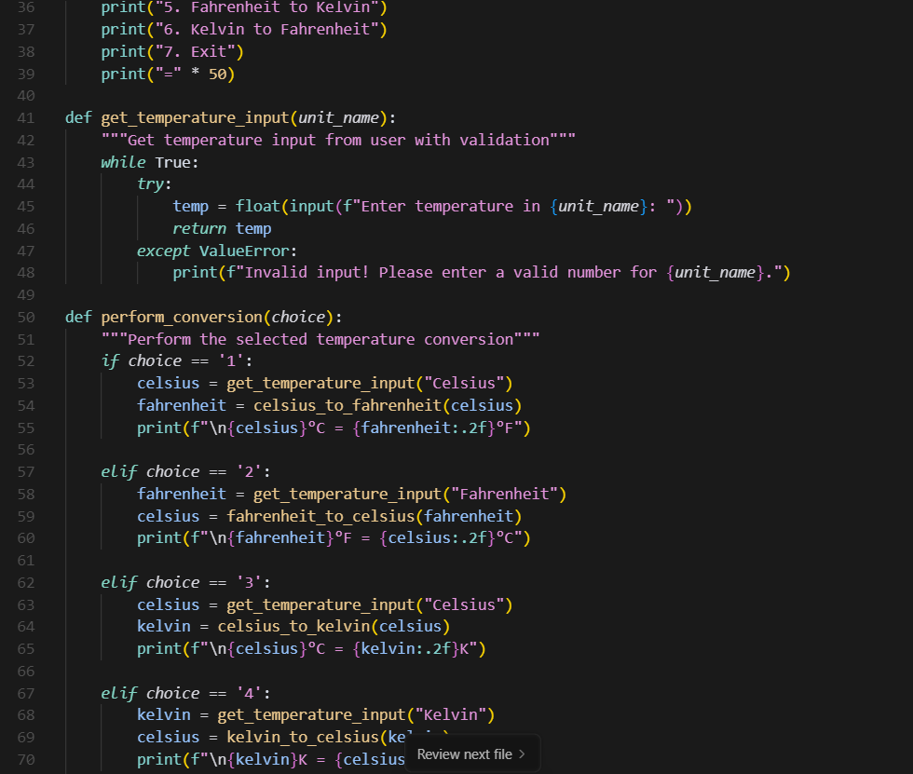

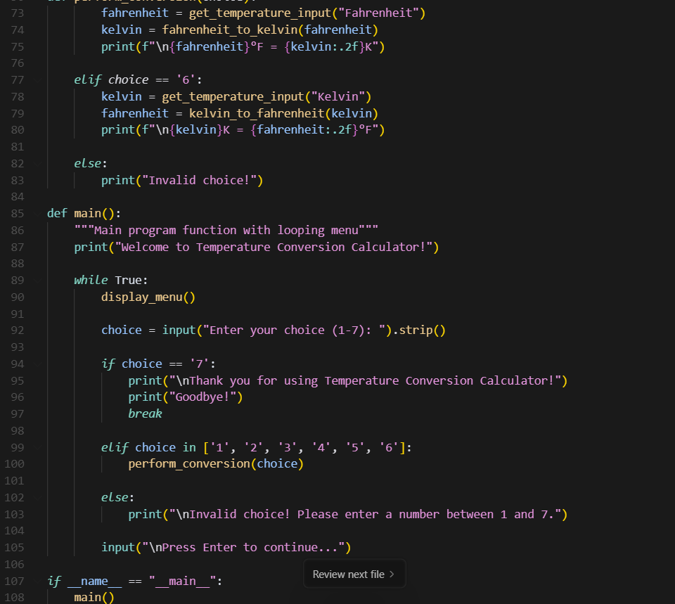

OUTPUT :

